European Cooperation: workshop on back and front office tools

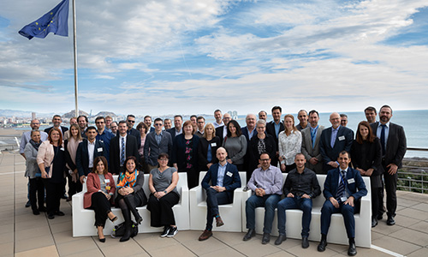

From 9 to 11 December, a back office and front office workshop takes place at EUIPO in the framework of its European Cooperation activity.

The back office and front office systems are currently implemented in the national and regional IP offices of more than 20 EU Member States, giving users **a full set of harmonised software tools to manage the full lifecycle of trade marks and designs.**

The systems, developed under [European Cooperation](https://euipo.europa.eu/ohimportal/en/european-cooperation) at EUIPO, fully support the transposition of the requirements of the Trade Mark Directive and the General Data Protection Regulation (GDPR) among other functionalities.

Agenda topics include an overview of the development process of the Software Package tools and the preliminary outline of the Strategic Plan 2025 in terms of the European Cooperation Projects.

The workshop also includes round table sessions during which representatives of national and regional IP offices will be able to share their experience with the implementation of back and front office tools.